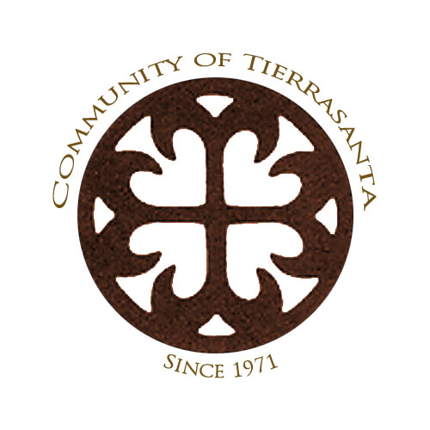
Tierrasanta Community Council
& Planning Group

Draft Minutes for Wednesday, May 21, 2014 Meeting
Tierrasanta Recreation Center • 11220 Clairemont Mesa Blvd.

The meeting was convened at 6:30 pm by TCC President Justin DeCesare. A quorum was present consisting of President DeCesare, Vice President Rich Thesing, Treasurer Russ May, Secretary Deanna Spehn (arrived at 6:37 pm), and the following Area Directors: Area 1 - William Turner;; Area 4 – Dawn Nielsen-Lostritto; Area 5 – Anthony Ferebee (arrived at 7:05 pm); Area 6 Loren Vinson; Area 7 – Bonnie Alexander, John Farmer and Rik Hauptfeld; Area 8 – Jennifer Schultz; and Commercial Director Tom “TK” Keliinoi (13 members out of 14 filled positions and 17 total positions). Absent: Area 3 Director Christy Patnoe. Vacant: Area 2, 3, and 4.

Representatives from Government Offices
Adam McElroy, Community Service Officer from the San Diego Police Department Eastern Division, and Lt. Steven Behrendt cautioned those present that when evacuation orders are in effect such as we saw in the north County fires, it is important to immediately respond.

Jason Bercovitch reported that Congressman Scott Peters, 52nd Congressional District, would be participating in several Memorial Day events. Congressman Peters supports increases in funding and reducing wait times at Veterans Administration facilities. Jason.Bercovitch@mail.house .gov

Katelyn Hailey announced that Senator Block has 11 bills on Suspense pending decisions by the Appropriations Committee. The office is always available to respond to problems with state agencies. (619-645-3133 Katelyn Hailey Katelyn.Hailey@sen.ca.gov)

Evan Bollinger introduced himself as the new representative for County Supervisor Dave Roberts (619-531-5533).

Cassandra Weinlein announced that City Councilmember Scott Sherman chairs the City’s Audit Committee. The Kumeyaay Lake Campground at Mission Trails Regional Park will re-open in mid-June. (619-236-6677 Cassandra Weinlein CWeinlein@sandiego.gov)

Item A: MCAS Miramar: Lt. Colonel Thomas Frederick, the Executive Officer at MCAS Miramar, described how aircraft traveling between Arizona and California in the vicinity of Marine air bases are integrated within civilian and military flight corridors, including communication handoffs.

Non Agenda Public Comment: Local resident Gene Balbo spoke in opposition to siting a proposed charter school in the shopping center at Tierrasanta Blvd. and La Cuenta due to increased traffic, risks to safety, and potential impacts to access to and from the fire station. Mr. Balbo was encouraged to follow the issue of the proposed Conditional Use Permit for the school on the TCC’s website at www.tierrsantacc.org so that he will know when the matter will be discussed at the Community Development Committee and at the full Tierrasanta Community Council.

Item B: It was moved by Thesing, seconded by Farmer and approved unanimously 12-0-1 with Nielsen-Lostritto abstaining due to absence, to approve the Draft Minutes for the April 16, 2014 TCC meeting, as submitted.

Action Item 1: President DeCesare described the appointment process to fill vacancies for Area Directors 2, 3 and 4, all At Large positions. It was moved by Thesing seconded by Ferebee and approved unanimously 13-0 to appoint Scott Hasson to the Area 3 position.

Action Item 2: La Mirage Renovation: The Irvine Company, owner of La Mirage, has a proposed $100 million renovation that is seeking approval from the Tierrasanta Community Council to amend Planned Development Permit PDP 98-0726, adding a 90-unit apartment building (134,225 square foot structure), a gated vehicular entry with manned guard station, street vacation to privatize an internal loop road and new community identification signage. It is anticipated that the project would go to the Planning Commission in July 2014 and to City Council in September 2014. Construction is proposed to begin in late 2014 with completion in mid-2016. Following an extensive presentation on the proposed improvements to the site, it was moved by Thesing, seconded by Ferebee and approved unanimously 14-0 to refer the proposed project to the TCC’s Community Development Committee.

Action Item 3: Dawn Nielsen-Lostritto, Chair of the Recognition Committee, reported that plans are well in place for the May 29th recognition event and sought volunteers to help set up prior to, and clean up after the event.

Action Item 4: President DeCesare circulated the draft list of committees and appointments to outside organizations so that TCC members and members of the public could indicate their interest in serving. The list will be voted on at the June TCC meeting. It is proposed that Standing Committees of the TCC would meet at least quarterly. President DeCesare proposed adding an Outreach & Communications Committee that could conduct surveys, use social media and improve outreach to the community on local issues.

Action Item 5: Treasurer Russ May provided a written Financial Report that will be posted on the website. During the discussion it was recommended that in the future Financial Reports will be submitted quarterly and posted on the website at that time.

Action Item 6: Concert in the Park Chair Anthony Ferebee announced that this year’s concerts would be held on June 29th, August 15th, September 5th and October 5th.

Action Item 7: The matter of reimbursing President DeCesare for the purchase of the Tierrasanta Community Council Banner was tabled until the June meeting.

Action Item 8: On March 19, 2014, the TCC convened the By-Laws Committee to respond to proposed changes by the City of San Diego Community Planners Committee and the City Attorney’s office for all planning group by-laws subject to Council Policy 600-24. President DeCesare reported that the By-Laws Committee has met and done a general review of the planning group bylaws and will return to the TCC with a draft when it is ready for review. It is expected that the committee will meet at least three times prior to holding a noticed public meeting to take input and make additional changes as required, prior to returning to the full TCC in the Fall of 2014.

Motion to Adjourn: It was moved by Thesing, seconded by Hauptfeld to adjourn the meeting at 8:30 pm.

Upcoming 2014 TCC meetings at 6:30 pm in the Tierrasanta Recreation Center:
June 18, 2014
July 16, 2014
August – No Meeting
September 17, 2014
October 15, 2014
November 19, 2014
December – No Meeting

