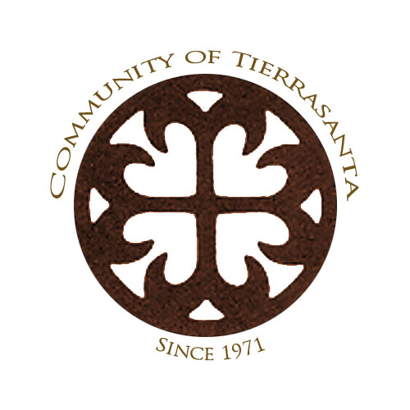
Tierrasanta Community Council
& Planning Group

Agenda for Wednesday, June 18th, 2014 Meeting
6:30 pm • Tierrasanta Recreation Center • 11220 Clairemont Mesa Blvd.

Please note: Unless an agenda item says “Time Certain,” items may be taken up earlier or later than the listed time on the agenda.

6:30 pm Pledge of Allegiance • Roll Call/Introductions – Determination of Quorum
Government Representatives: limited to 2 minutes each
Fire Dept: Station 39 Battalion Captains Julie Bardsley, Carl Becker, Scott Lowe http://www.sandiego.gov/fire/
Police Department: Adam McElroy, Community Service Officer and/or Lt. Steven Behrendt
Congressman Scott Peters: 858-455-5550 Jason Bercovitch Jason.Bercovitch@mail.house.gov
State Senator Marty Block: 619-645-3133 Katelyn Hailey Katelyn.Hailey@sen.ca.gov
Assemblyman Brian Maienschein: 858-689-6290 Rob Knudsen robert.knudsen@asm.ca.gov
Assemblymember Shirley Weber: 619-462-7878
County Supervisor Dave Roberts: 619-531-5533 Evan Bollinger Evan.Bollinger@sdcounty.ca.gov
Mayor Kevin Faulconer: 619-236-6630 Anthony George – georgea@sandiego.gov
Councilmember Scott Sherman:
Deputy City Attorney: 619-236-6220
Board of Education: 619-838-5274 Kevin Beiser kbeiser@sandi.net
MCAS Miramar: 858-577-6603 Juan Lias juan.lias@usmc.mil

6:45 pm Item A: MCAS Miramar Fire Department: MCAS Miramar Fire Chief, James Magill, will give a briefing on the recent wildfires in San Diego County, and the efforts the local military play in San Diego Fire Fighting efforts.

7:10 pm Item B: Non-agenda Public Comment: Any member of the public may address a community issue not elsewhere on this agenda. Each speaker may take up to 2 minutes; speakers may be limited to less time if several speakers have filed speaker slips to speak on the same issue. The TCC is prohibited from acting on or voting on any issue that is not already on the agenda. Issues raised during Non-Agenda Public Comment will be referred to the appropriate TCC Committee.
7:15 pm Item C: Agenda Review / Requests for Continuance / Additions to the Agenda
7:20 pm Item D: Approval of the Draft Minutes for the May 21st, 2014 TCC meeting.
Supporting Material: http://www.tierrasantacc.org/wp-content/uploads/2014/06/Draft-TCC-May-21-2014-Minutes.doc

7:25 pm Action Item 1: President DeCesare will oversee the appointment process to fill the vacancies for the following Area Directors: Area 4 and Area 8. If eligible candidates are present to be appointed to the seats at tonight’s meeting, they will be considered for appointment. All three positions have been converted to At Large positions by a unanimous vote at the March 19, 2014 TCC meeting. Candidates must have attended a TCC meeting in the 12 months prior to the meeting and reside or own property within the 92124 zip code, and be present in person at the April 16, 2014 meeting in order to be appointed. If no eligible appointees are present, the positions will remain vacant until the next TCC meeting when the process will be repeated. Tonight’s actions are to fill the positions and/or continue the item until the July 16, 2014 TCC meeting.
Supporting Material: http://www.tierrasantacc.org/wp-content/uploads/2012/11/Tierrasanta-Community-Council-Planning-Group-Bylaws-7-16-2008.pdf

7:30pm Action Item 2: Elevate Elementary CUP: Elevate Elementary has received its
charter from the San Diego Unified School District and is seeking approval on a Conditional Use Permit to operate an elementary school located 10791 Tierrasanta Blvd, as well as for the use of the parking lot and field located at 10881 Tierrasanta Blvd. Tonight’s action, pending a vote from the Community Development Committee, is to vote on the Tierrasanta Community Council’s recommendation of the permit.
Supporting Material: http://www.tierrasantacc.org/event/community-development-committee-meeting-re-cup-for-charter-school-at-newbreak-church-site/
http://www.tierrasantacc.org/wp-content/uploads/2014/06/Draft-MOU-Newbreak-Church-3-1.docx

7:50pm Action Item 3: The TCC consists of several sub-committees that assist in making recommendations to the council as a whole for various matters. Tonight’s action is to make changes as needed and vote upon the final list of Tierrasanta Community Council Committees for June 2014 through May 2015, and as well to convene any newly formed ad hoc subcommittees.
Supporting Material: http://www.tierrasantacc.org/wp-content/uploads/2014/06/6-12-14-Current-Committees-of-the-Tierrasanta-Community-Council.docx

8:00pm Action Item 4: Vector Control Program: The San Diego Parks and Recreation department Open Space Division has been working with Helix Environmental to identify possible sites to address the abatement of mosquito breeding areas in Tierrasanta. Helix Environmental Planning has applied for a Site Development Permit for the vector control project adjacent to Calle De Vida. Tonight’s Action is to hear the presentation and take action as required.
Supporting Material: https://www.mediafire.com/folder/exqv4k8xgn59e/Villa_Trinidad_Vector_Control_Project_SDP

8:20 pm Action Item 5: Report by Concerts in the Park Chair Anthony Ferebee on this year’s series of concerts. Tonight’s action is to accept the report and take action as required.

8:25 pm New Business Item 6 - TCC will consider items that may have been added to tonight’s agenda, consistent with Council Policy 600-24 and the Brown Act, if there is a two-thirds vote by the TCC members to add the item(s).

8:30 pm Item 7 Adjournment – A two-thirds vote by the TCC is required to extend the meeting for 30 minutes beyond 8:30 pm. A vote is required for each 30-minute extension of the meeting.

Upcoming 2014 TCC meetings at 6:30 pm in the Tierrasanta Recreation Center:
Vote by the TCC on the proposed additions/modifications to La Mirage Apartments
July 16, 2014
August – No Meeting
September 17, 2014
October 15, 2014
November 19, 2014
December – No Meeting

Please note: The City of San Diego requires that in order for a member of a planning group to be indemnified for actions taken related to their role as an advisory committee member to the city on land use matters, planning group members are required to attend at least one Community Orientation Workshop (COW). All council officers, directors, and committee members understand that they are required to take this training and adhere to what is promulgated therein.

