Lake Hodges at 295 ft — What It Means for Water Rates in Tierrasanta
Briefing for the Tierrasanta Community Council
Date: September 17, 2025

Key Takeaways

Keeps upward pressure on rates lower by restoring local storage and operations that reduce dependence on more expensive imported water.
- Improves regional reliability by re-activating the Hodges↔Olivenhain connection for emergency storage and two-way flows.
- Context on 2026 rates: SDCWA approved an 8.3% wholesale increase for 2026 (smaller than earlier forecasts). Restoring Hodges operations helps moderate future increases by reducing reliance on higher-cost imports and improving system efficiency.
- Enhances fire-season readiness with more water available locally and restored hydropower/pumping flexibility.

Why Lake Hodges Matters to Tierrasanta
Tierrasanta buys retail water from the City of San Diego. The City’s largest cost component is wholesale water from the San Diego County Water Authority (SDCWA). When SDCWA can store more water locally and operate more efficiently, the City faces less upward cost pressure—and that flows through to neighborhoods like Tierrasanta.

What Changes at 295 ft
When Lake Hodges is held around 295 ft (still well below the physical crest):
- More Usable Storage
  - The Hodges–Olivenhain system was designed to provide substantial emergency/local storage (≈ up to 20,000 acre-feet).
  - At the currently restricted low level (~280 ft), usable storage is only a fraction of that.
- Two-Way Pumping + Hydropower Back Online
  - The deep pump station can move water both directions between Hodges and Olivenhain Reservoir and generate hydropower when releasing downhill.
  - With a higher lake, those operations become economically meaningful again (lower net energy/ops costs, better system flexibility).
- Less Reliance on High-Cost Imports (At the Margin)
  - Extra local storage lets SDCWA time purchases and buffer dry spells, which helps trim the size of future wholesale increases versus a “low-lake” status quo.

How Savings Reach Tierrasanta (The $$ Path)
Hodges (295 ft) ──↔── Olivenhain ──→ SDCWA system ──→ City of San Diego ──→ Tierrasanta customers
↑ storage & ops restored lower wholesale pressure retail bills reflect pass-throughs
- Restored storage & operations reduce some upstream costs/risks for SDCWA.
- The City’s wholesale bills are heavily driven by SDCWA rates.
- Over time, this reduces the upward pressure on City retail rates that Tierrasanta residents pay.
Expect moderation, not miracles: This won’t slash bills overnight. But it can mean smaller future increases than we’d otherwise see.

Benefits Beyond Rates
- Reliability & Resilience: More emergency storage inside the county; greater operational flexibility during droughts, outages, or aqueduct disruptions.
- Fire-Season Readiness: More local water available and restored “water-on-the-hill” flexibility to support regional firefighting needs.
- Energy Co-Benefits: Pump-turbines can offset some operating costs and provide grid support.

Quick FAQ
Q: Does 295 ft make the dam unsafe?
A: No. 295 ft is well below the historic maximum elevation. Engineering controls and oversight remain in place; the point is to restore practical operations while long-term dam work proceeds.
Q: Will this immediately lower my bill?
A: Not instantly. It’s about cost-pressure relief at the wholesale level that flows through into retail rates over time.
Q: Who benefits?
A: All City of San Diego customers, including Tierrasanta, because the City’s largest expense is SDCWA wholesale water.

What We’re Asking of the Tierrasanta Community Council
- Adopt a resolution supporting raising Lake Hodges toward ~295 ft to restore storage and the Hodges↔Olivenhain pump station operations.
- Encourage coordination among the City, SDCWA, and regulators to prioritize operational steps that safely enable this level.
- Educate residents that this action helps moderate future rate increases, improves reliability, and supports fire readiness.

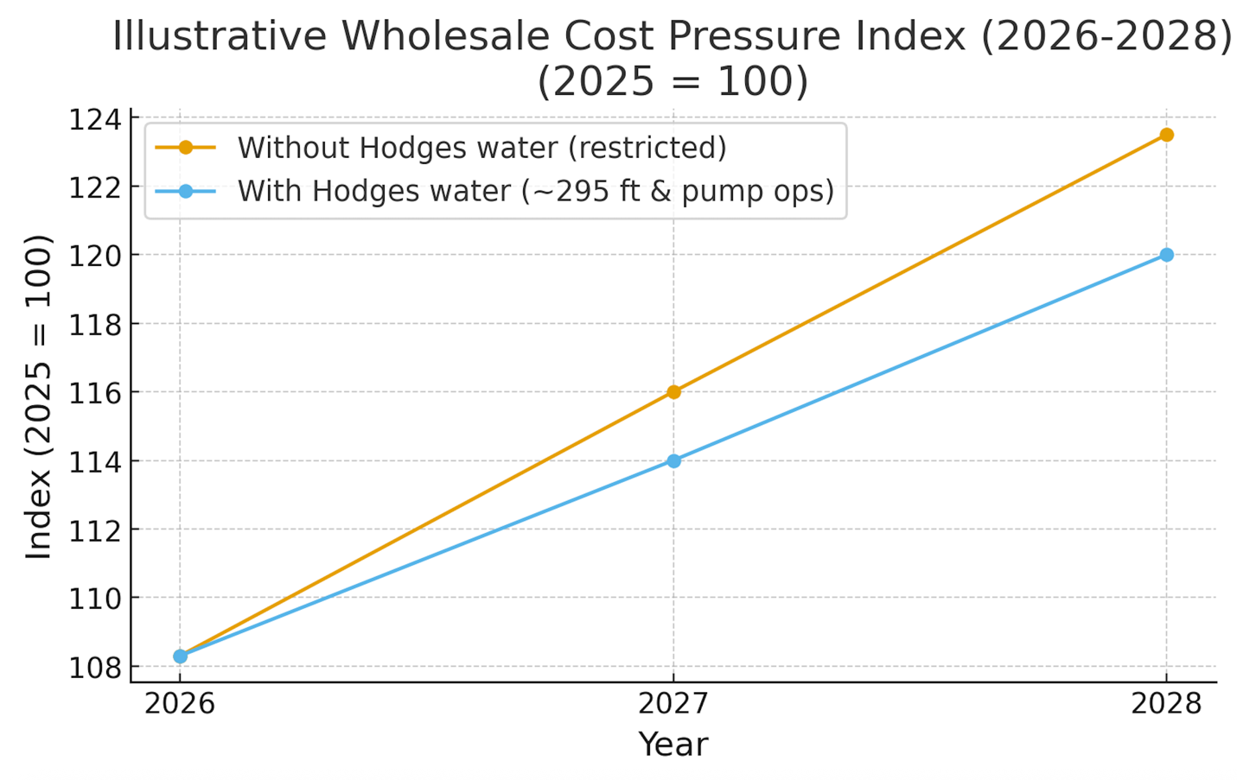

Contact:

PaulBernsteinMD@gmail.com
www.RaiseLakeHodges.org

